Module (JQueryBasic,Effects& Advanced) – 5
- What is jQuery?
Ans : jQuery is a small, light-weight and fast JavaScript library
- How to Apply CSS Using JQuery, How to Add Class and Remove Class in Jquery ,JQuery Animation?
Ans :To apply CSS using jQuery
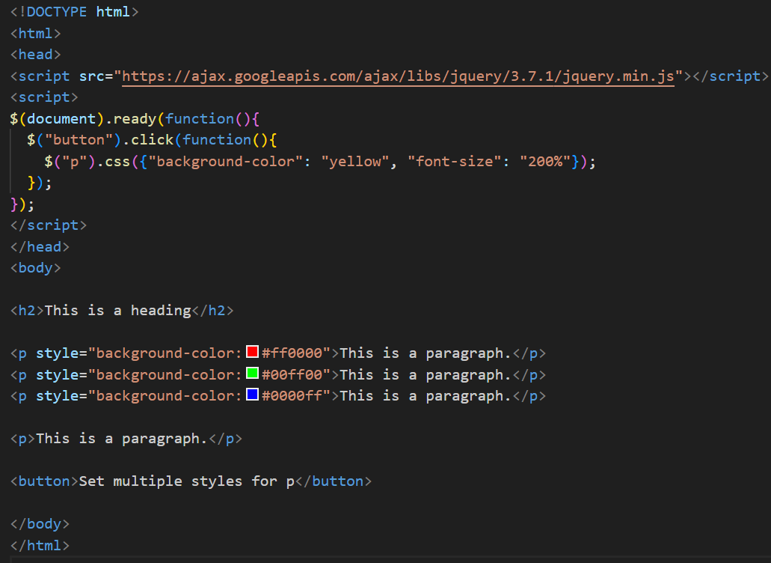
Add Class
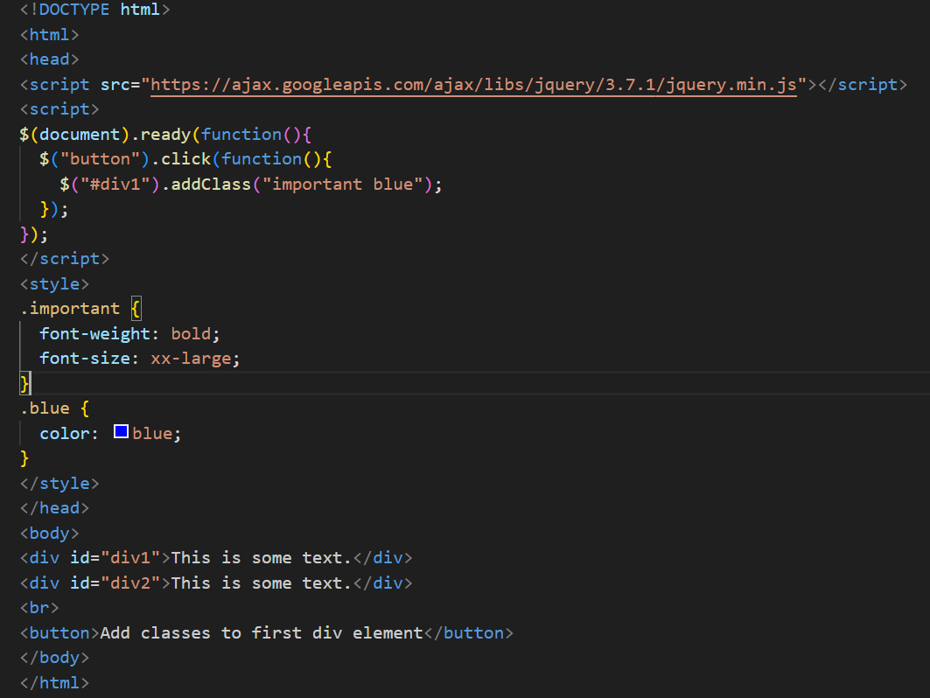

Remove Class
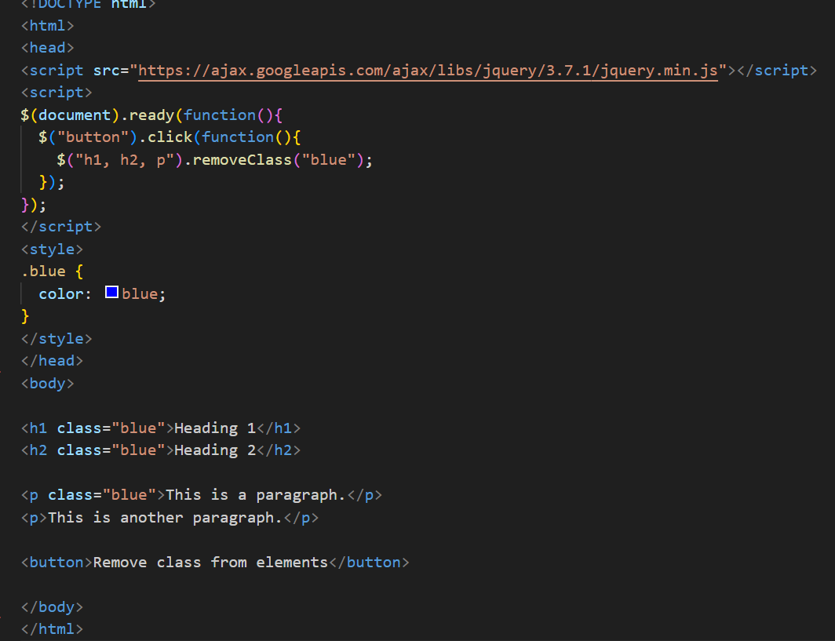
JQuery Animation
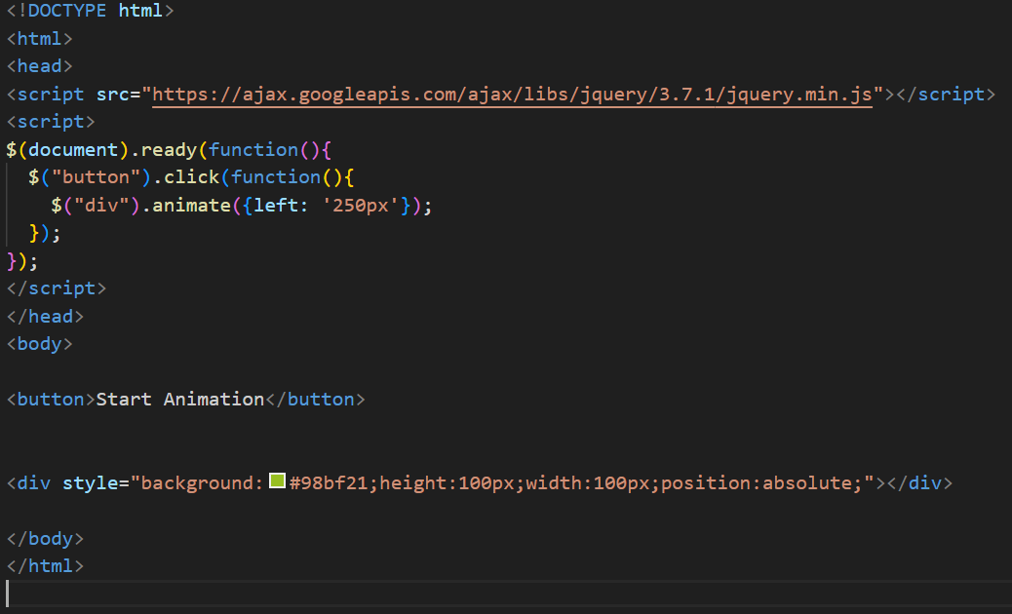

3.How to create slider with animation?
Ans :To create a slider with animation using jQuery:
